1.WEB API HANDSON
Objectives:
- Explain the concept of RESTful web service, Web API & Microservice
  - Features of REST architecture - Representational State Transfer, Stateless, Messages, Concept of Microservice, Difference between WebService & WebAPI, Not restricted to send XML as response
- Explain what is HttpRequest & HttpResponse
- List the types of Action Verbs
  - HttpGet, HttpPost, HttpPut, HttpDelete - Meaning of action verbs and how that should be declared as attributes for Web API
- List the types of HttpStatusCodes used in WebAPI
  - Ok, InternalServerError, Unauthorized, BadRequest - All thru the action result types
- Demonstrate creation of a simple WebAPI - With Read, Write actions
  - Structure of a web api - Controller & its inheritance from ApiController, Action verbs, Action method
- Explain the types of Configuration files of WebAPI
  - Startup.cs with depdency injection, appSettings.json, launchSettings.json, Explain Route.config & WebAPI.config in .Net 4.5 framework

- First Web Api using .Net core
Create a .Net core web application with API template. Use the option to create controller with Read Write permissions. Notice the ValuesController creation with Action methods corresponding to the Action verbs.
On creation of the Web API, execute the application and check if the GET action method result is returned as expected. 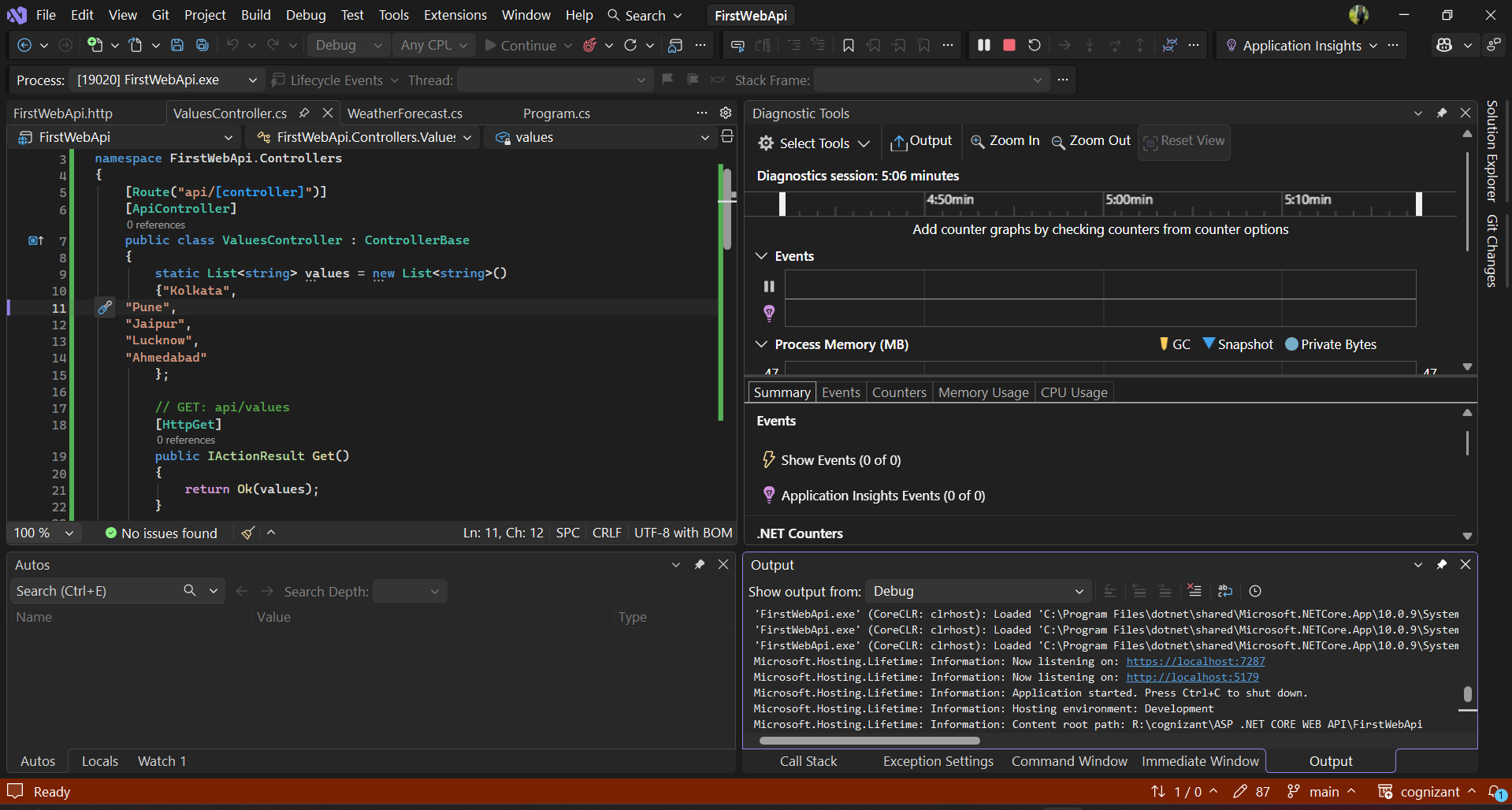
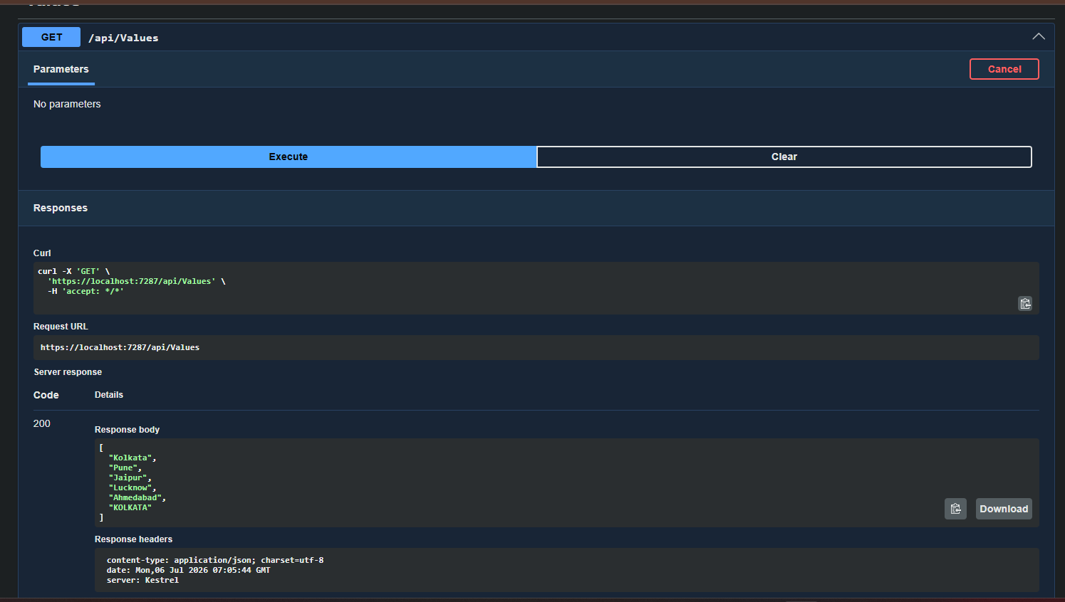
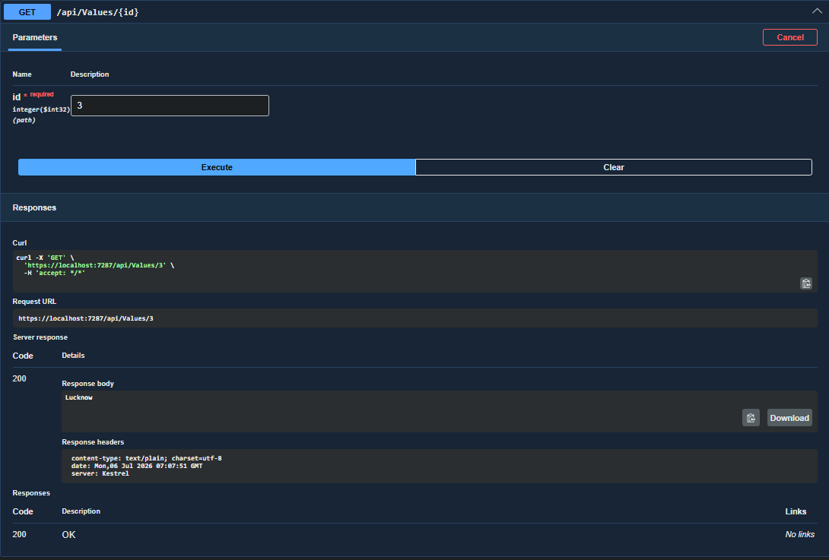

2.WEB API HANDSON
- Web Api using .Net core with Swagger
Create a .Net core web application with API template. (Use existing application if created). Install Swashbuckle.AspNetCore Nuget package. Post this do the following steps in Startup.cs
- In ConfigureServices method, add the code provided below.
services.AddSwaggerGen(c =>
{
c.SwaggerDoc("v1", new Info
{
Title = "Swagger Demo",
Version = "v1",
Description = "TBD",
TermsOfService = "None",
Contact = new Contact() { Name = "John Doe", Email = "john@xyzmail.com", Url = "www.example.com" },
License = new License() { Name = "License Terms", Url = "www.example.com" }
});
});
- In Configure method, add the code provided below.
app.UseSwagger();
app.UseSwaggerUI(c =>
{
// specifying the Swagger JSON endpoint.
c.SwaggerEndpoint("/swagger/v1/swagger.json", "Swagger Demo");
});

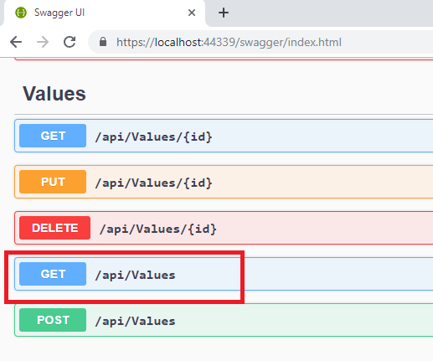
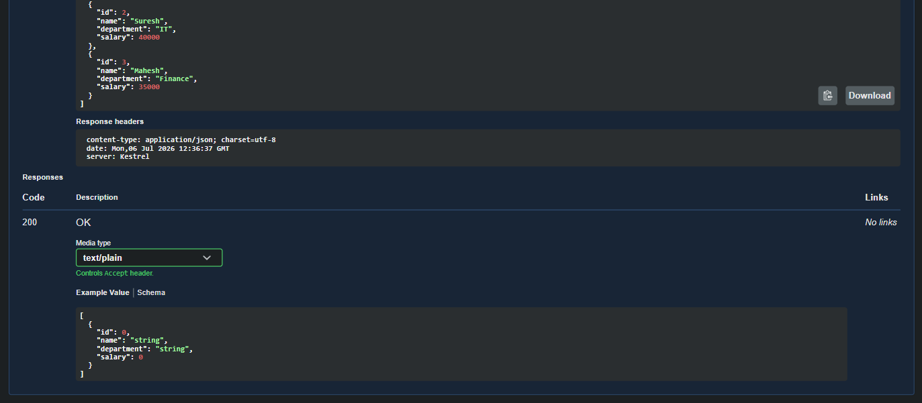
It opens a panel which has ‘Try it out’ button. Click that and Click ‘Execute’ button. 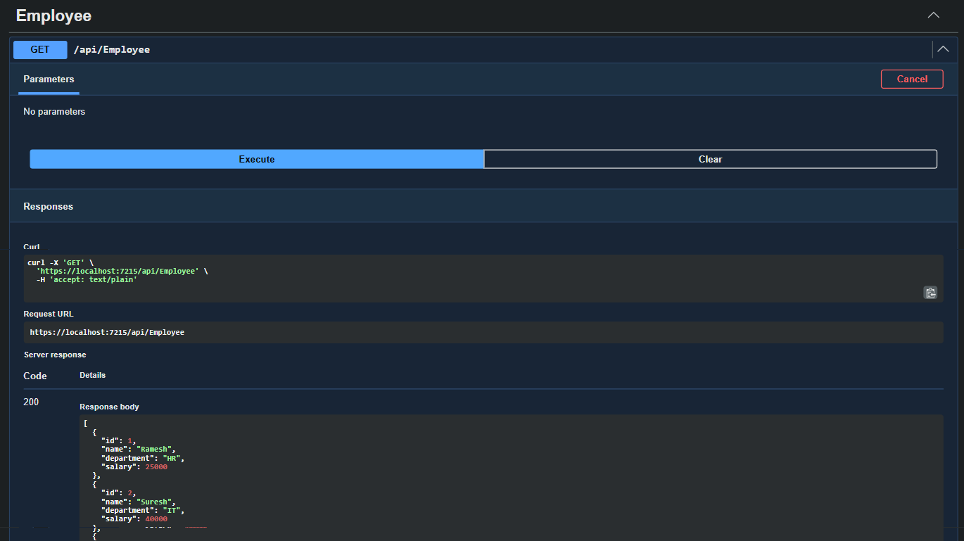

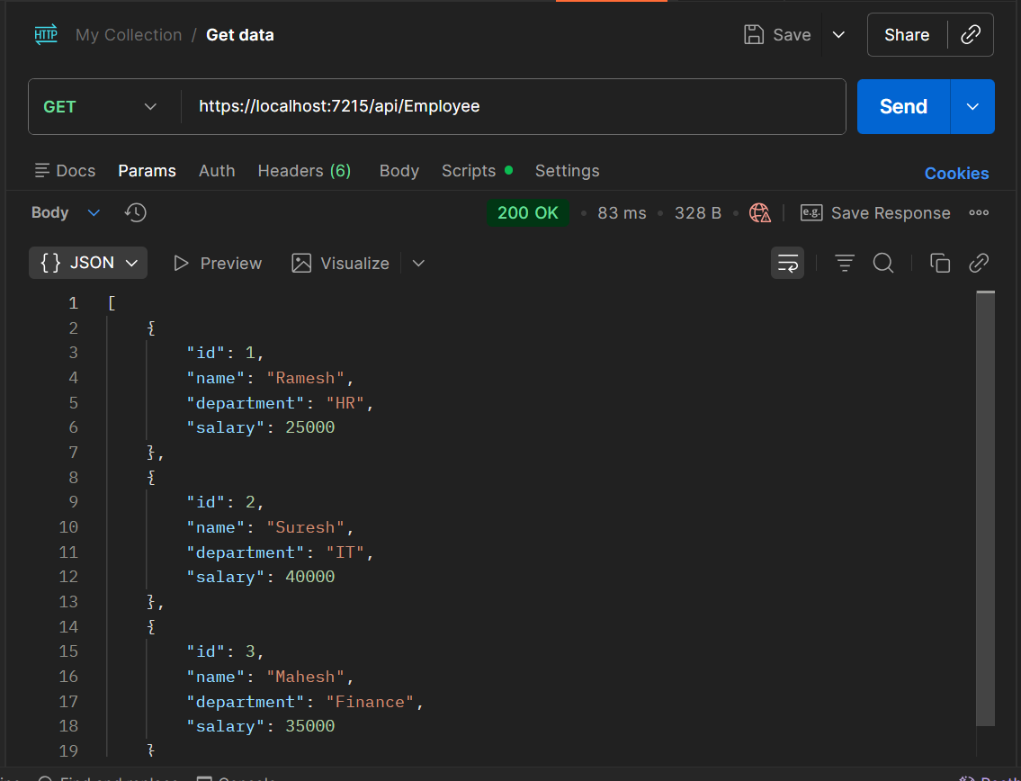
Use POSTMAN tool, to point to the local Web API that was created with Employee controller. Test the GET action method using POSTMAN.Verify the output if the List of employees are listed in the ‘Body’ part of the GET window on POSTMAN tool. 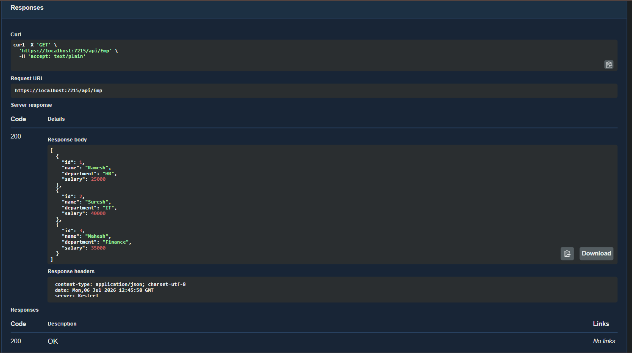
Modify the Controller name in the Route attribute of the Employee controller to ‘Emp’ and check its access thru POSTMAN 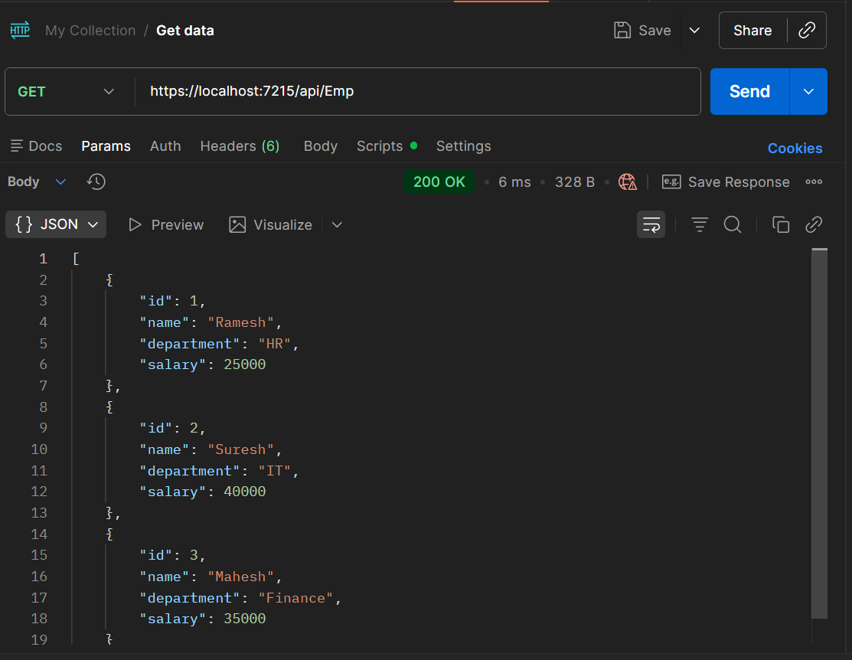

3.WEB API HANDSON
Objectives:
- Demonstrate creation of an Action method to return list of custom class entity
  - Model class creation, Use AllowAnonymous attribute, Use HttpGet action method
- Explain the usage of FromBody attribute
  - Read the model object from request, other than the query string parameter
- Demonstrate Custom filter
  - Usage of ActionFilterAttribute, OnActionExecuting method to intercept the request, Create filter for Custom exception - Need to install Microsoft.AspNetCore.Mvc.WebApiCompatShim package
- Web Api using custom model class
Create a Custom class ‘Employee’ of the below defined structure
public class Employee
{
public int Id { get; set; }
public string Name { get; set; }
public int Salary { get; set; }
public bool Permanent { get; set; }
public Department Department { get; set; }
public List<Skill> Skills { get; set; }
public DateTime DateOfBirth { get; set; }
}

Create a new controller - EmployeeController with Read Write actions
Constructor: Create few records, HTTPGet, HTTPPost/HTTPPut
Create a Private method GetStandardEmployeeList that returns a List of Employee class. Invoke this method in the Get action method of the EmployeeController that was created in the previous step.
Public ActionResult<Employee> GetStandrad()
Modify the return type of the Get action method(without parameter) to return List of Employee class object
Add ProducesResponseType to the GET action method for Status code 200
Check the Swagger description for the GET method for success status code

Create a Custom action filter for Authorization.
The requirement is to intercept incoming requests and check if there is a key ‘Authorization’ in the request header or not. If it is there, then to check if it contains a value ‘Bearer’ or not.

Create a folder ‘Filters’ in the application solution. Create a class ‘CustomAuthFilter’ to filter requests. Inherit ActionFilterAttribute. Override OnActionExecuting method to check if the request object has Header ‘Authorization’ or not. If not, throw BadRequestResult with the message
Invalid request - No Auth token
If the header is present, then check if the value contains the word ‘Bearer’. If not, throw BadRequestResult with the message
Invalid request - Token present but Bearer unavailable
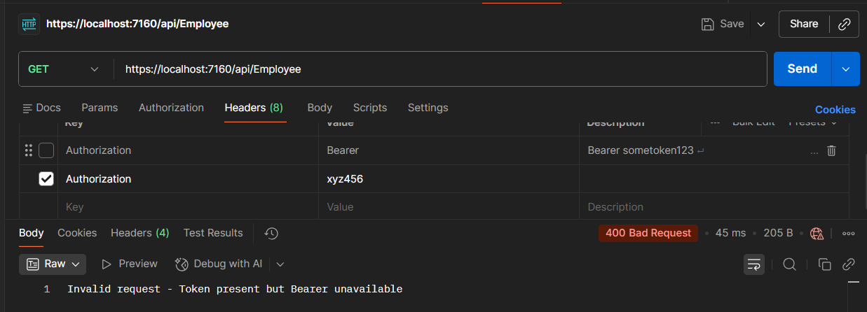
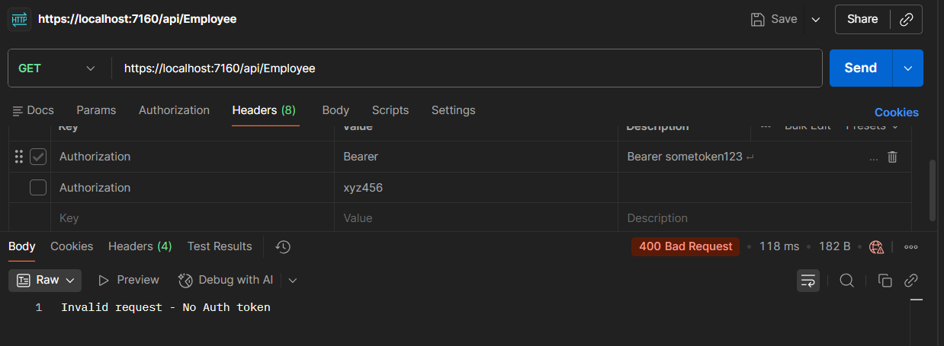
Add an attribute CustomAuthFilter to the Employee controller to filter any request to check for the Authorization token in the request header.

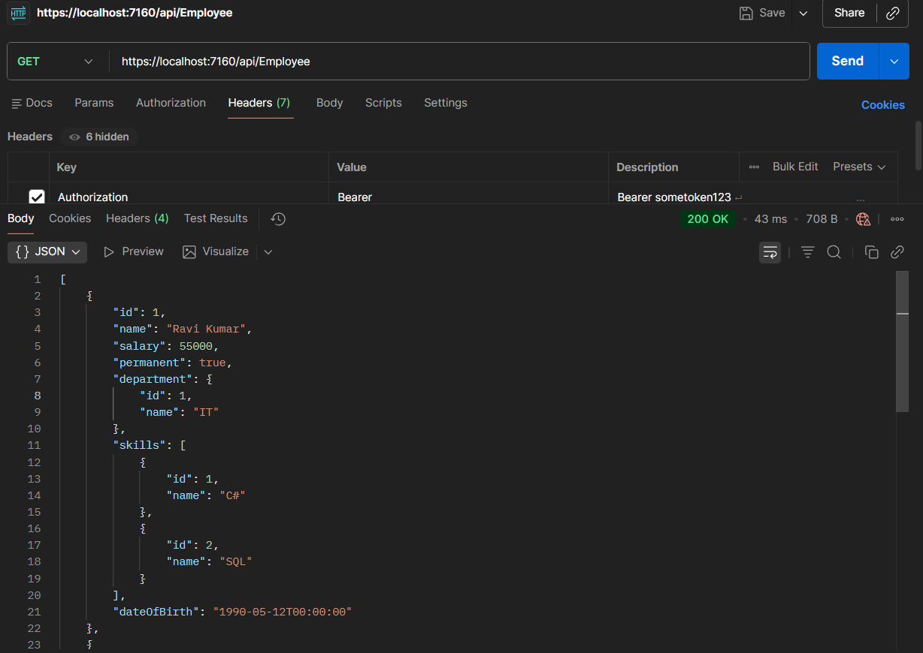
Custom Exception filter
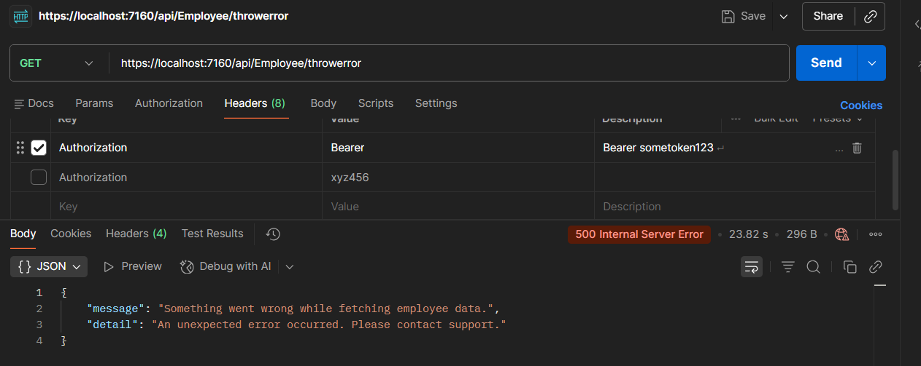
Create a class ‘CustomExceptionFilter’ to catch the exceptions occuring the application. Implement IExceptionFilter thru the OnException method
Use the exception context to fetch the exception detail. Capture that and write it to a File in the system.
Set the Result property of the exception context to ExceptionResult.
Throw an exception in GET action method.
Ensure that the GET action method has ProducesResponseType for 500 - Internal server error
Use Swagger to test the exception and message being thrown.
Note: This needs WebApiCompatShim NuGet package installation
4.WEB API handson
Objectives:
- Demonstrate creation of an Action method to perform data create, update & delete operation
  - Use FromBody attribute, extract data to custom model class using FromBody attribute, use hardcoded data to update & delete data, Use Swagger and POSTMAN to test
- Web Api CRUD operation
Update Employee data as per the input thru Web API PUT action method call
Employee information has to be updated based on the user input. Use Swagger tool to invoke the action method mapped with Http PUT action verb to update an employee data.
Modify the action method to return Employee data thru ActionResult.
Check if the id value is lesser than or equal to 0. If true, throw BadRequest action result with the message ‘Invalid employee id’ 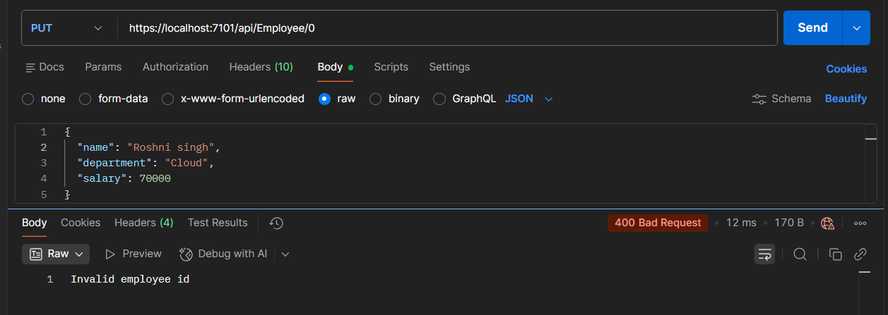

If the value is greater than 0 but not available in the list of employee ids that is there in the hardcoded list of employees, throw BadRequest action result with the same message as stated above.

If the id value is valid, use the JSON data from the input body and update the hardcoded list. Filter the employee list data for the input id and return that as the output.
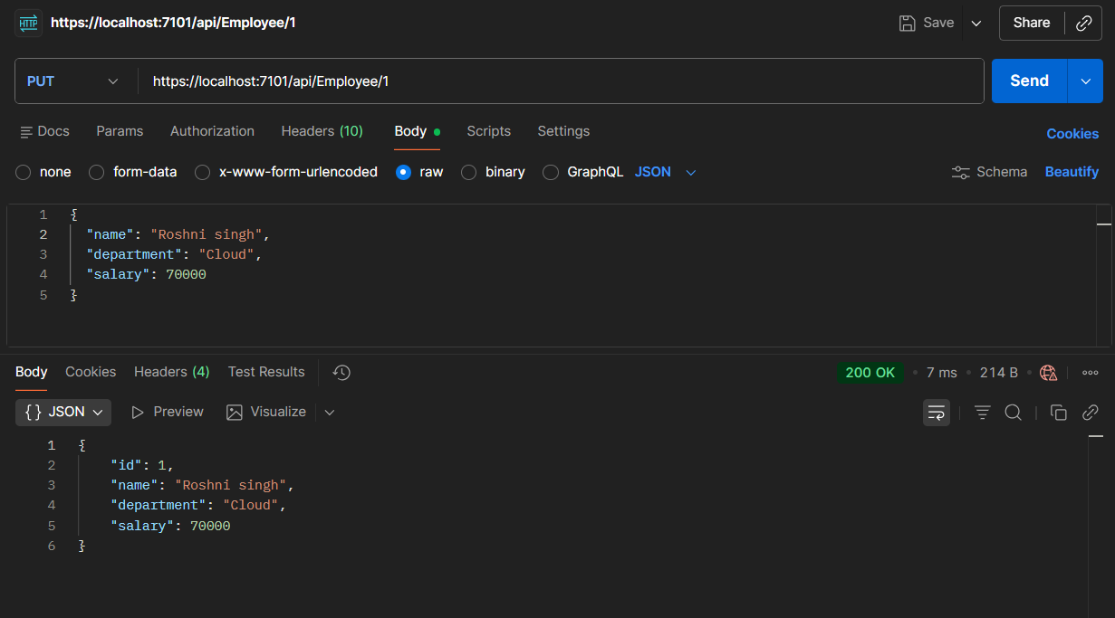

5.web api handson
Objectives:
- Explain CORS enablement for Web API access for local application
  - What is CORS?, How to enable CORS thru Startup.cs, Install Cors nuget package to Web API application
- Demonstrate security in WebAPI
  - Bearer and Jwt token authentication, Use Authorize attribute & send roles in Jwt token, Setting in Startup.cs for AddAuthentication and AddJwtBearer with validation attributes, UseAuthentication, AllowAnonymous to AuthController to generate token, Claims
- JsonWebToken
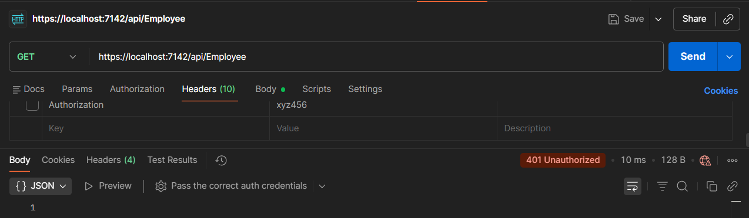
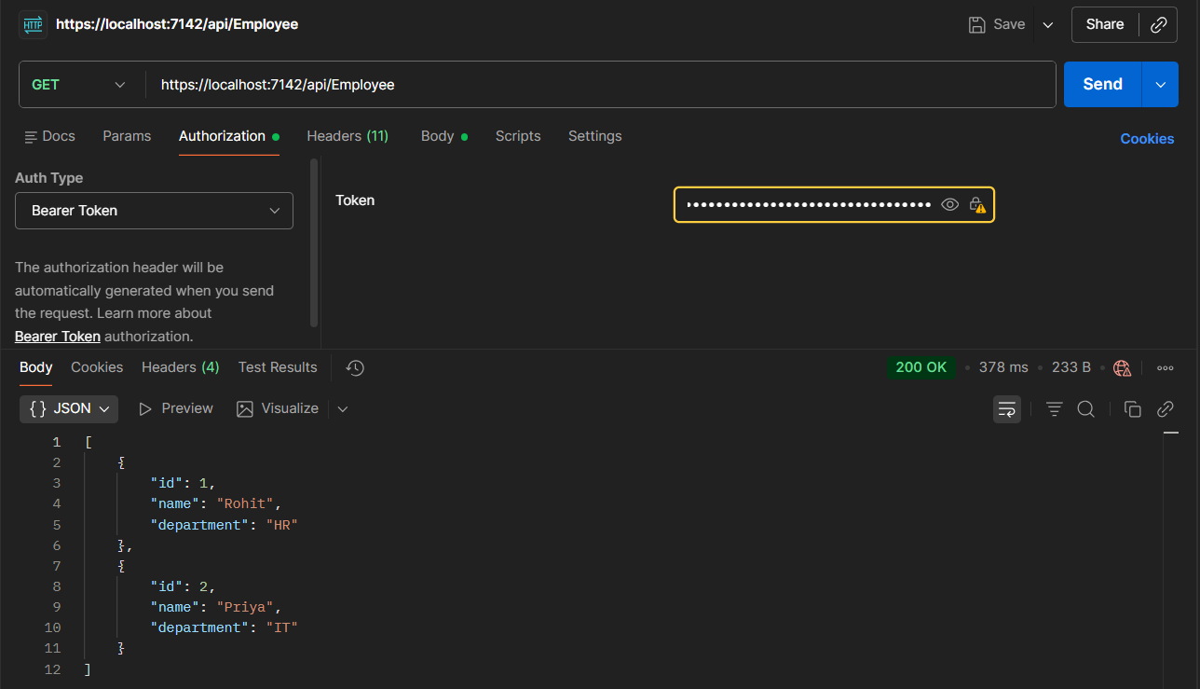

6.Kafka Integration with C#:
Outline:
- Introduction to Kafka
- Kafka Architecture
- Topics
- Partitions
- Brokers
- Kafka plug in .NET
- Installation of Kafka
- Basics of Zookeeper
- Demo
Hands On:
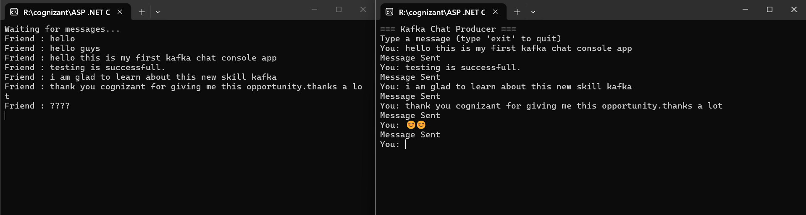
- Create a Chat Application which uses Kafka as a streaming platform and consume the chat messages in the command prompt.
- Create a Chat Application using C# Windows Application using Kafka and consume the message in different client applications.
